Thoracic Vascular Injury
Stem: A 56y old male is brought by EMS to the ER with a self-inflicted GSW to the chest. He was intubated en route, has two 16g IVs in antecubital fossa and has no other signs of trauma. He lost pulses in the ambulance bay.
A left anterolateral thoracotomy is immediately performed.
Describe steps of ER Thoracotomy:
- Left arm above head, 4th interspace incision from sternum to bed with retractor handle pointed towards axilla.
- Longitudinal pericardiotomy anterior to phrenic nerve.
- Mobilize inferior pulmonary ligament.
- Manual compression of heart and/or Cross clamping of the descending aorta
- Right mainstem intubation and placement of OGT

Dark blood is noted upon pericardiotomy. Upon inspection it appears there is a laceration to the left ventricle. How would proceed?

- Extend pericardiotomy to deliver heart into the left chest.
- Temporary control with manual pressure.

If you have insufficient exposure? Convert to clamshell thoracotomy

How do control the Hemorrhage in the trauma bay?
- Manual pressure
- Skin stapler for cardiac injuries
- Foley catheter with inflated balloon
- Inflow occlusion

Describe Inflow occlusion?
- Manual occlusion of Right atrium or manual occlusion of SVC/IVC,
- Lift heart. Effectively causes inflow occlusion.

You were able to repair, this maneuver causes the heart to arrest, how to restart?
  - Restart heart by rewarming with warm saline, cardiac message and intracardiac epinephrine
  - Defibrillation with internal paddles set between 10-30 joules.
  - May need to bolus bicarbonate.

How do you repair?
- Atrial laceration
  - Clamp with satinsky clamp and oversew the line with 3-0 prolene
If unable to control with clamp?, Run it closed.

- Small ventriculotomy
Repair with interrupted 4-0 prolene sutures. (Don’t have time for pledgets)

- Laceration close to coronary artery
  - Deep horizontal mattress suture underneath coronary

- Transected coronary
If distal, tie it off. If proximal, patient is probably dead. Still tie off as
it isn’t practical to do bypass
Watch for EKG changes.

Pelvic Fracture with intraperitoneal bladder rupture.
Stem: A 22 year-old is on a motorcycle group ride when he crashes his motorcycle on the highway. He is helmeted. He is thrown approximately 30 feet. The patient is found unconscious by emergency medical services (EMS).
He is hypotensive with systolic blood pressure in the 80s. He responds to a 1 L normal saline (NS) fluid bolus by EMS, and systolic blood pressure is now 100 mm Hg.
Upon arrival to the trauma bay, he is awake but confused. He is tachycardic with heart rate in the 140s. Systolic blood pressure is back in the 80s. He is given 2 units of uncrossmatched O positive blood. He is complaining of lower abdominal pain and significant bilateral hip pain.

What would you like to do now?
- ATLS (ABCDE) (Airway, breathing, circulation, disability, exposure).
- Two wide bore 16-18 gauge IV cannulas. Obtain blood for labs (Type and screen / cross match, CBC, CMP, Coags, lactate).
- Secondary Survey:
-Pelvic ring instability: How? applying gentle pressure from the lateral aspect of each iliac wing with both hands.
-Lower extremity abnormal rotation.
Blood at uretheral meatus.
DRE
- Chest and pelvic films.
- FAST.
The patient in the scenario undergoes a chest x-ray with no acute findings Pelvis x-ray shows:
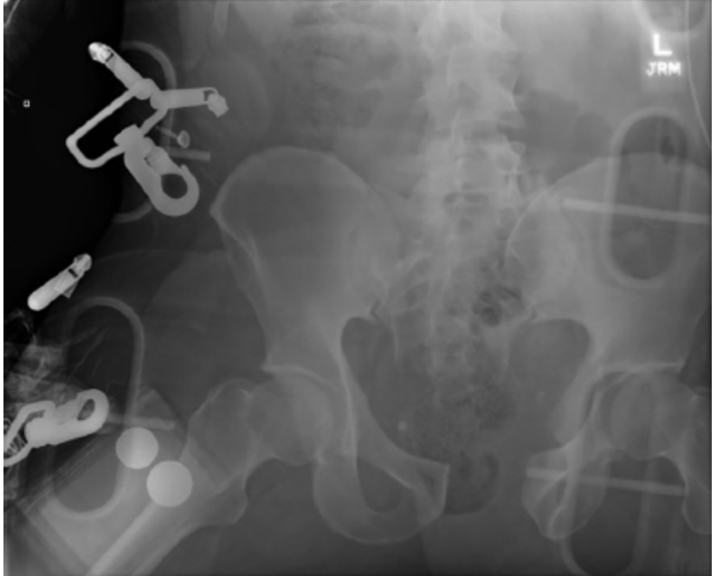
Widening of the pubic symphysis. There is diastasis of the right sacroiliac (SI) joint.
Now what? Pelvic binder
- The patient was resuscitated according to ATLS guidelines. He stabilized after transfusion of 2 units of blood in the trauma bay. A pelvic binder was placed. FAST was positive for fluid in the pelvis.
Now what? CT imaging.
- CT imaging.
  - A large volume of contrast-enhanced urine was identified within the peritoneum on delayed images. (To the examiner: consistent with urine extravasation and not contrast from pelvic vasculature)
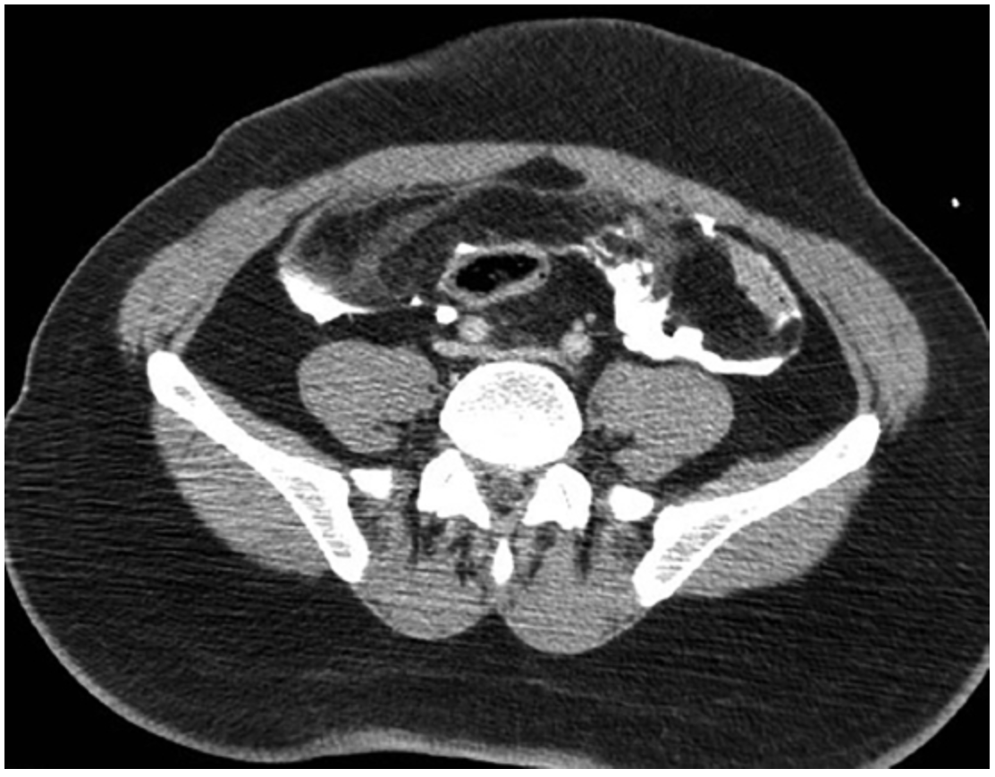
- An “open-book” pelvic fracture. You get 3-D reconstruction image.
- 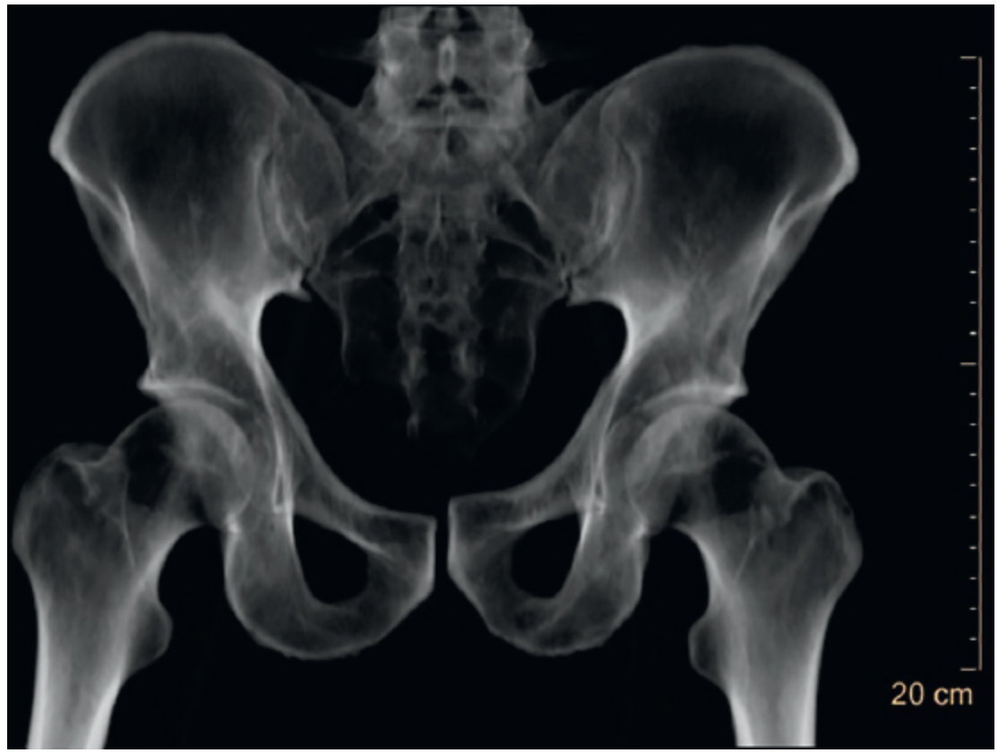

What is your diagnosis and what is your next step?
- Intraperitoneal bladder rupture and open book pelvic fracture.
- Ex. Lap: Limited incision as extending the incision below the semilunar line may lead to further hemorrhage by increasing anterior extension of a pelvic hematoma.
- Bladder repair. How?
  - Assess trigone and ureters.
  - Two layers.
  - Test repair by instilling 200 mL of normal saline into the bladder, clamp the foley and assess for leak.
  - Leave Foley.
- Ortho were involved and the patient underwent open reduction and internal fixation of pelvic fracture with a plate and closed treatment of right SI joint diastasis.
Scenario: Same patient, CT showed contrast extravasation in the pelvis and the patient remained hemodynamically stable after blood transfusion. Then what?
Angioembolization
Scenario: Same patient , patient was hemodynamically, stabilized with blood transfusion CT showed contrast extravasation in the pelvis. After CT patint became again hypotensive. You proceeded to the OR for ex.lap. Describe?
  - Ex. Lap: Limited incision, stay above the semilunar line. (Extending the incision below the semilunar line may lead to further hemorrhage by increasing anterior extension of pelvic hematoma) Tightly packing the pelvis intraperitoneal.
  - Preperitoneal packing with separate lower incision.
  - Temporary abdominal closure.
  - Postoperatively, the patient may need to be managed with angiography and embolization if there is continued hemorrhage.
  - Once stabilized, the patient can be returned to the operating room for re-exploration. Stabilization of the pelvis fracture, either internal or external, may be considered in conjunction with orthopedics.

